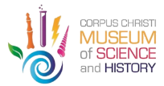
PRESS RELEASE

MEDIA CONTACT:
Susannah Urban
PR & Communications
C.C. Museum of Science & History
361.826.4672
SusannahU@ccmuseum.com

FOR IMMEDIATE RELEASE

The Friends of the C.C. Museum of Science & History Are Pleased to Receive Grant Awarded by the Texas Historical Foundation

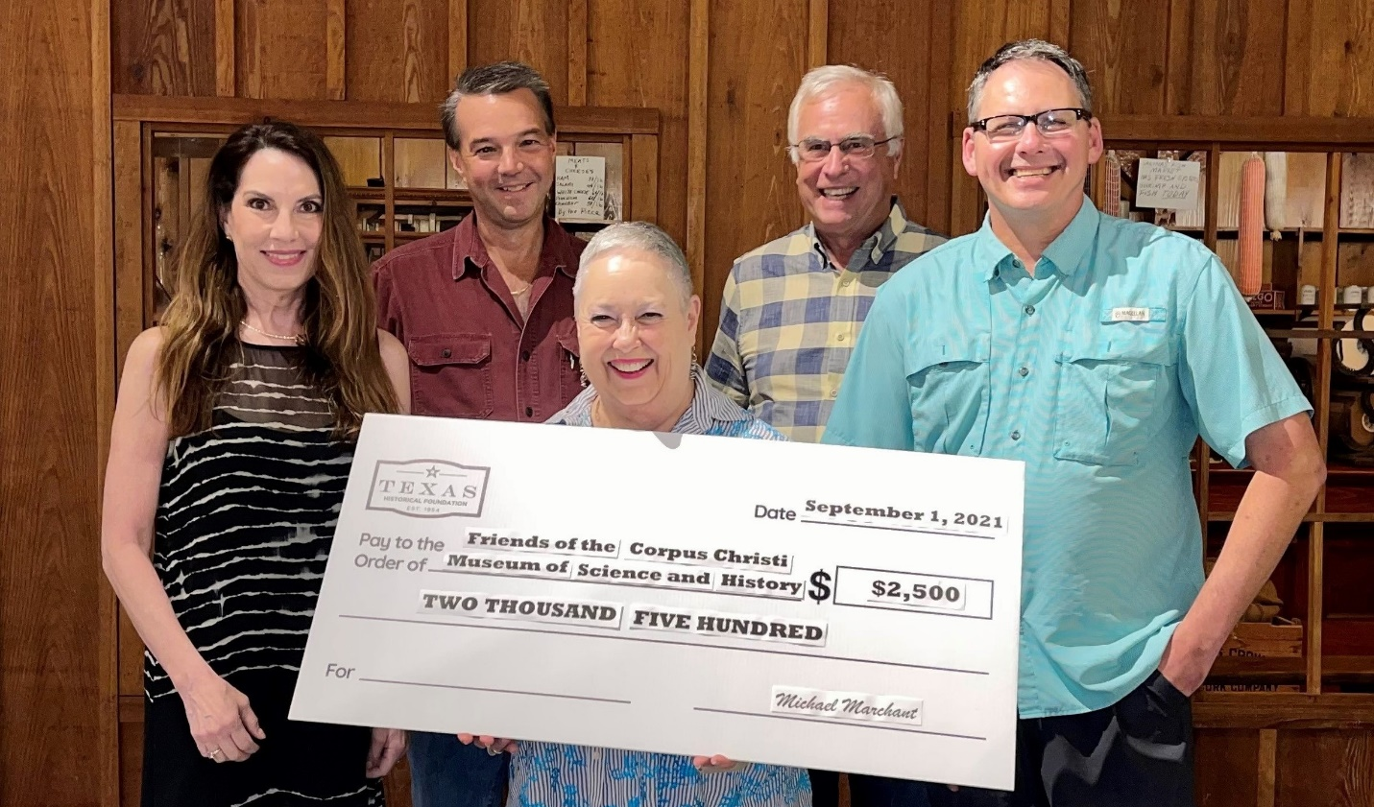
The grant funding will go toward the C.C. Museum's history outreach program for elementary school students throughout the Coastal Bend using Museum LIVE! actors and educators.
(CORPUS CHRISTI, TX, SEPTEMBER 2nd, 2021) — The Friends of the Corpus Christi Museum of Science and History is pleased to announce that they have been awarded a grant from the Texas Historical Foundation. The grant funding will support the implementation of the Corpus Christi Museum of Science and History's education outreach program for elementary school students in the Coastal Bend.

The C.C. Museum's education team is actively planning and producing the history outreach program. The program will serve CCISD and other schools beginning September 20th. An educator and an actor will bring history to life for students through a specialized curriculum and the Museum LIVE! Interactive Theater program. The Museum will present its live programming four days a week at the local schools through March 2022.

Since 1954, the Texas Historical Foundation has funded preservation and education projects around the state and helps promote the cultural legacy of Texas. Among the group's primary efforts is its award-winning Texas HERITAGE magazine and a preservation grants program. For more information or to join the Foundation, use the online membership form found on the organization's website, www.texashistoricalfoundation.org.

###

